Champion Manufacturing

**Website :** <https://championchair.com>

**Note : Please add your feedback in red colour. Thank you**

**#01 - 2571 | 2571**

* **Using the model name as the search term**

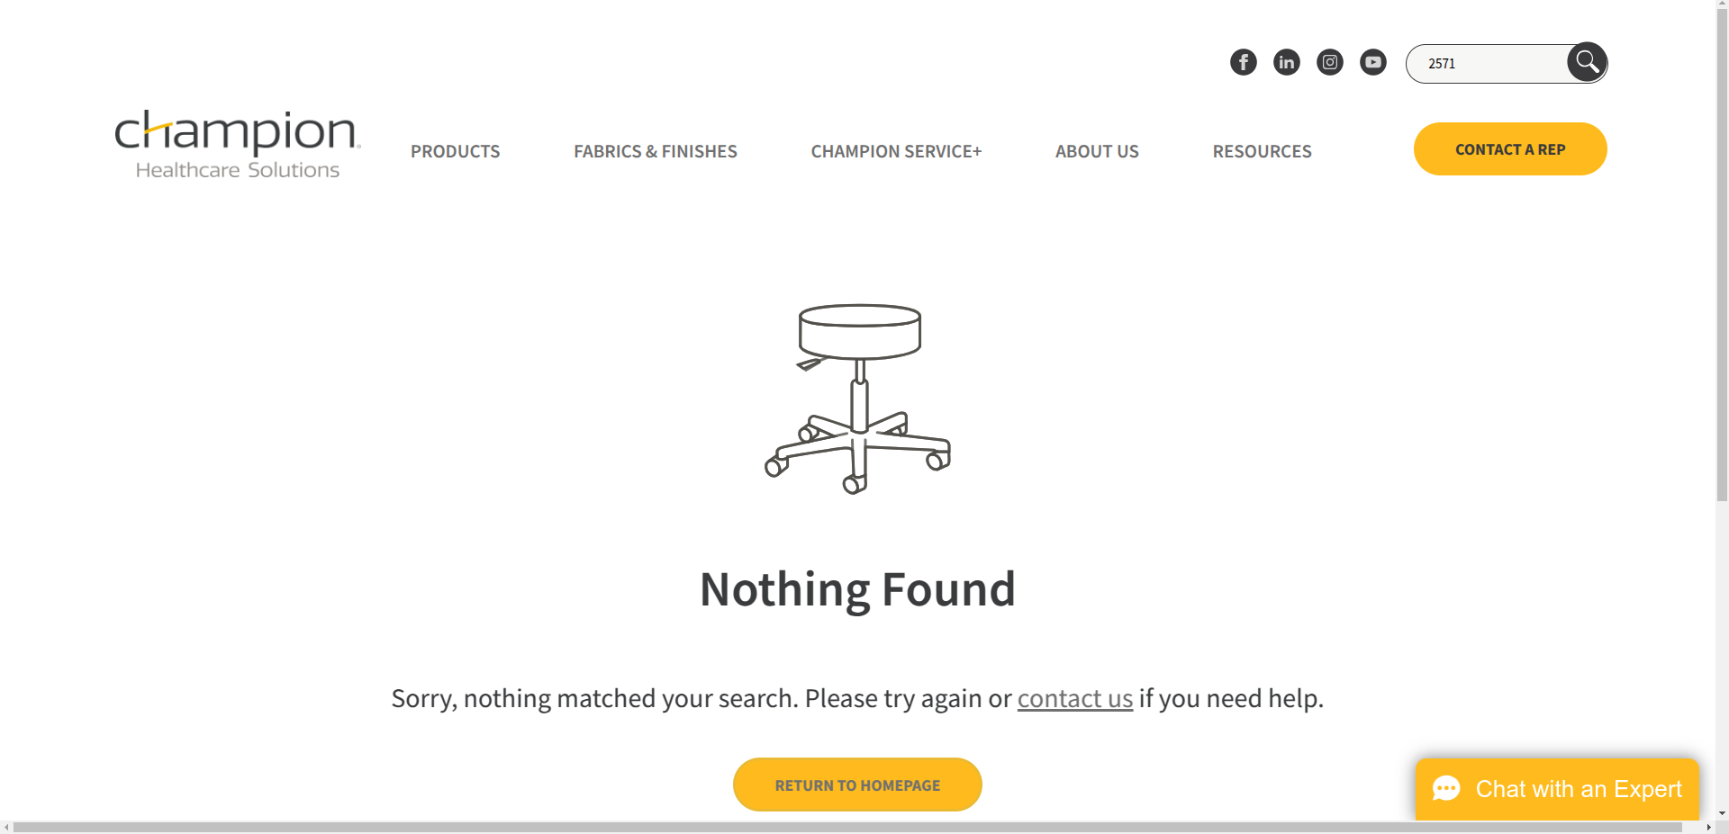

* **Using the mfr number as search term**



**Response:**

**#02 - 2573 Padded Vinyl | 2573**

* **Using the model name as the search term**

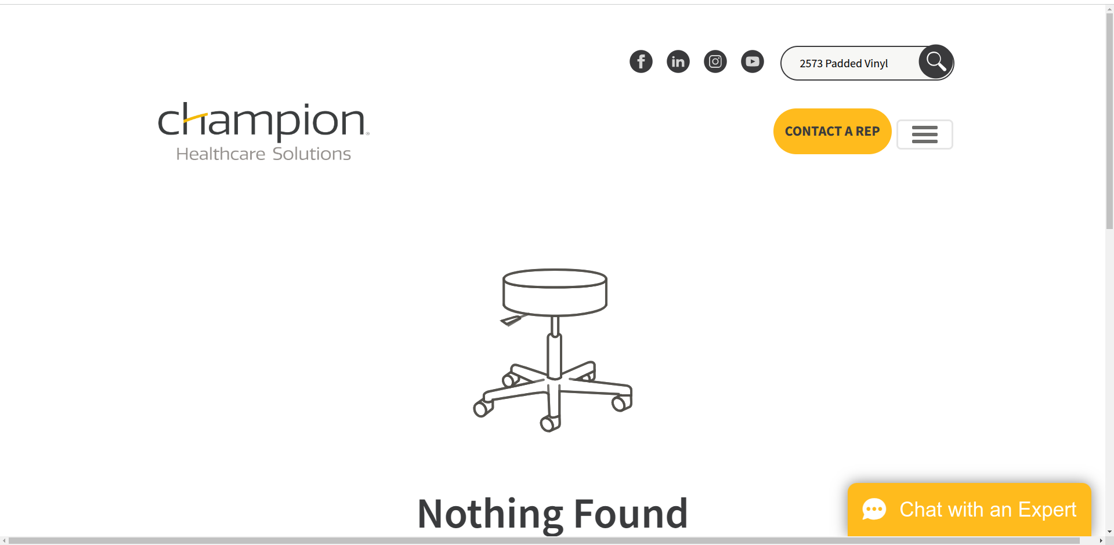

* **Using the mfr number as the search term**

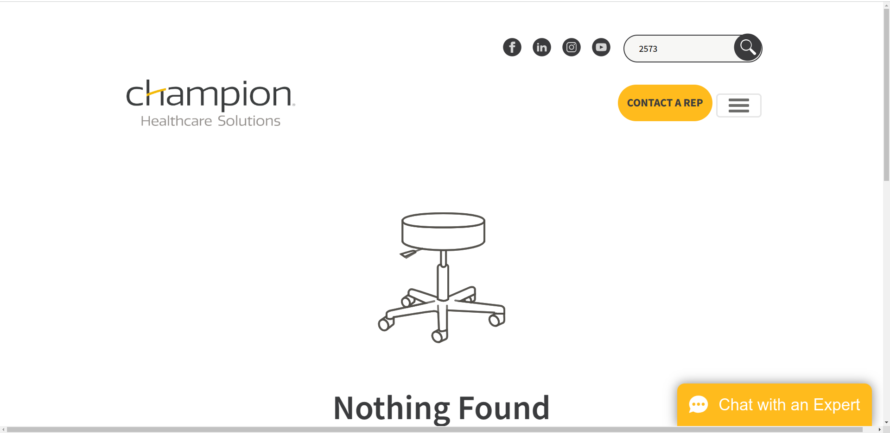

**Response:**

**#03 - XL Padded 2575 | 2575**

* **Using the model name as the search term**

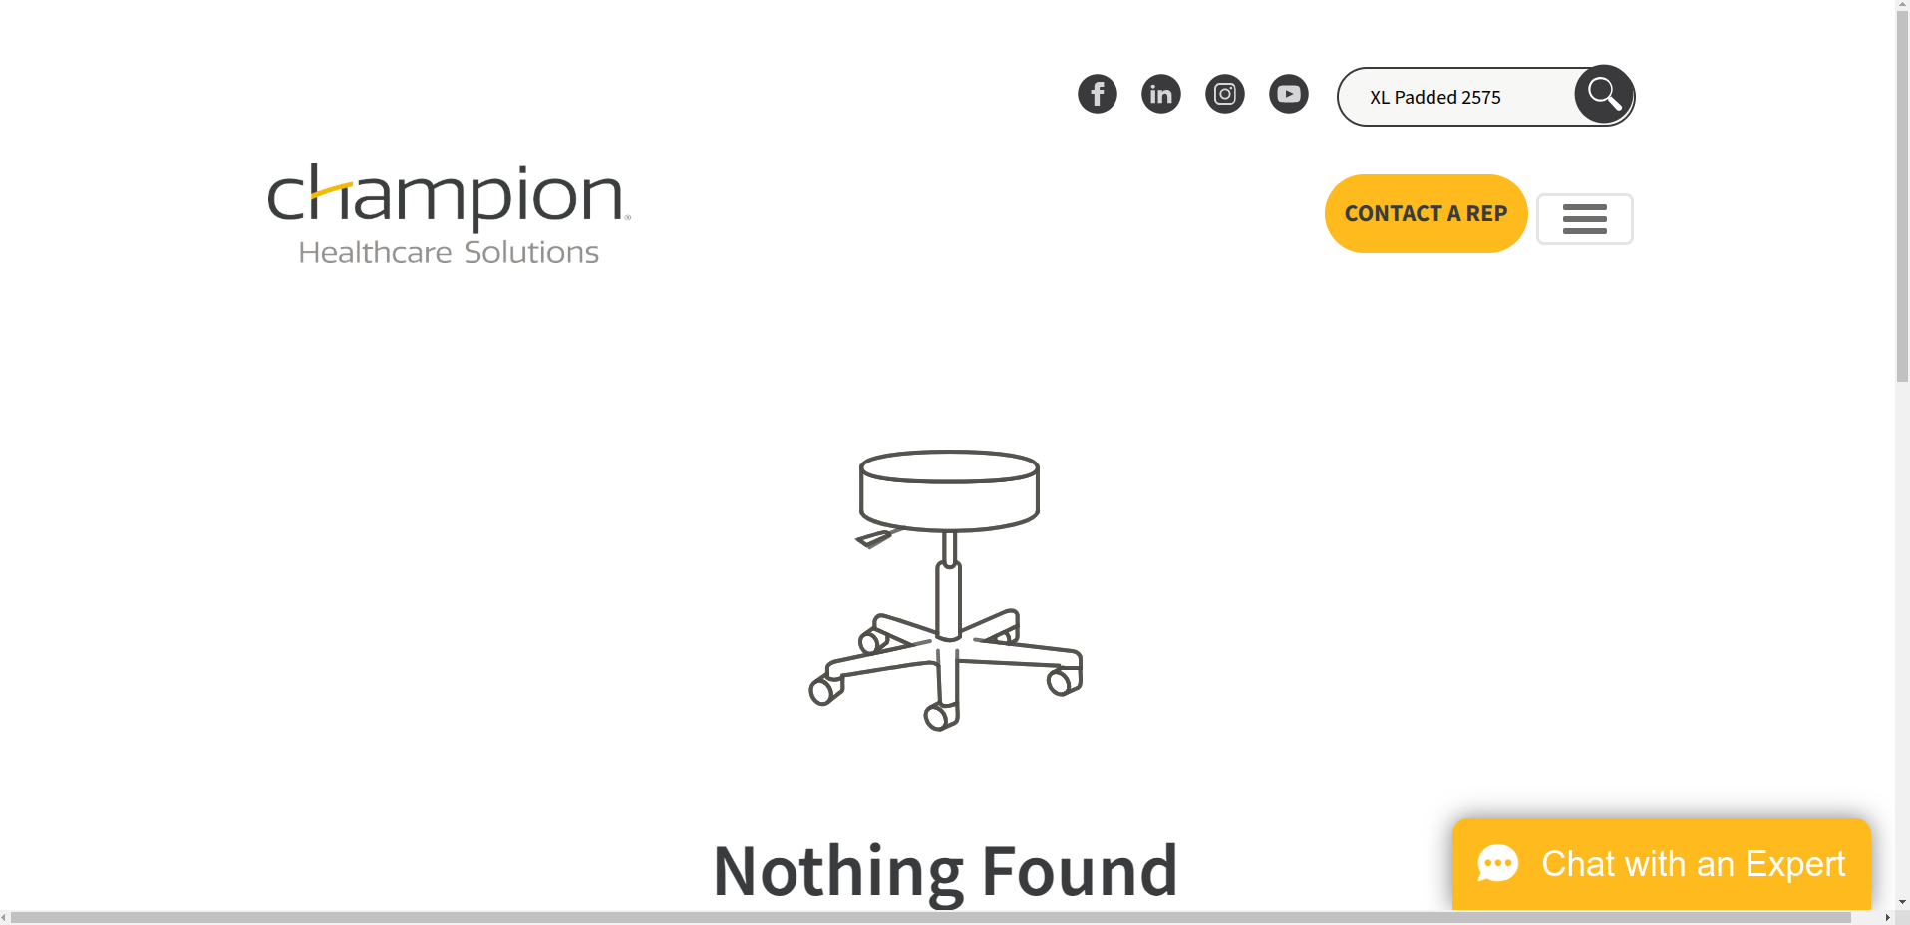

* **Using the mfr number as the search term**

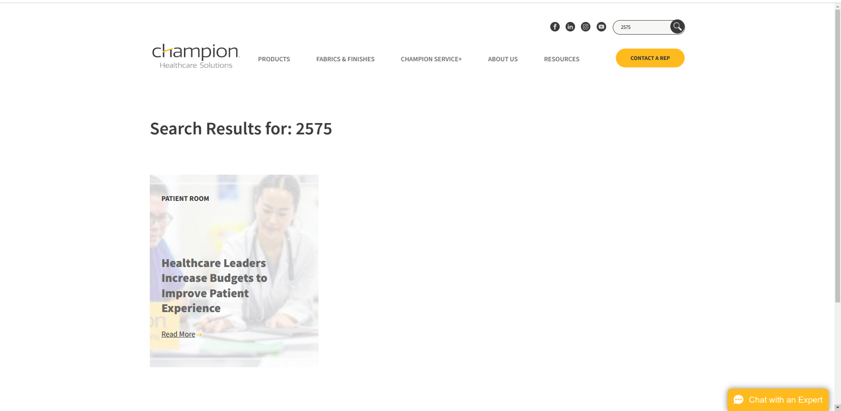

**Result:**



**Response:**

**#04 - XL Padded Chair with Cabinet 2574 | 2574**

* **Using the model name as the search term**

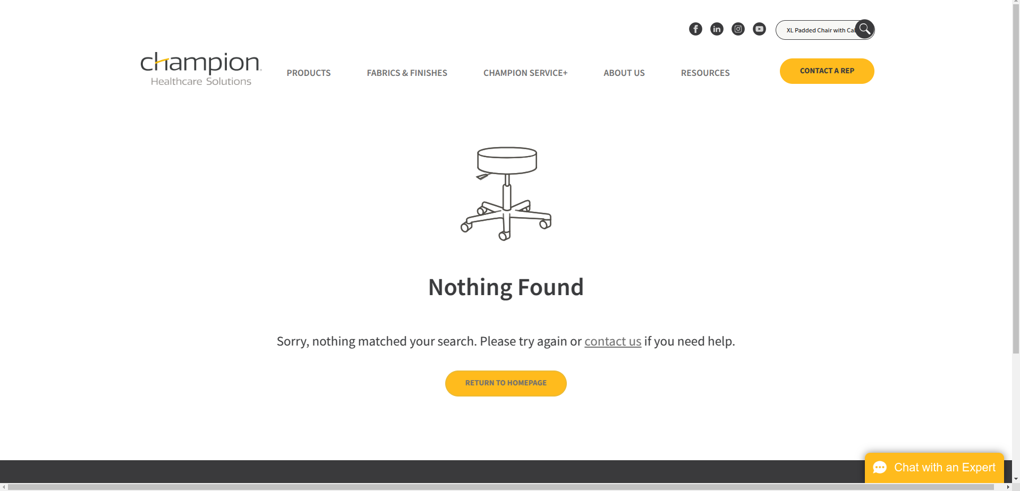

* **Using the mfr number as the search term**

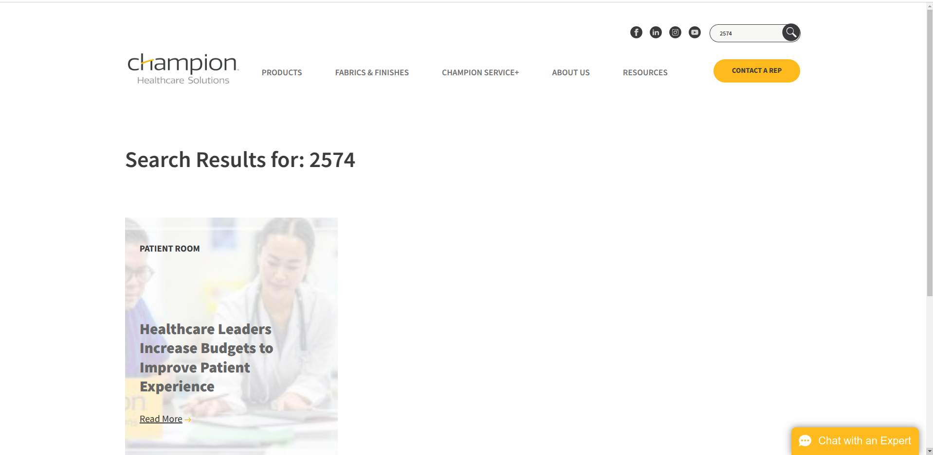

**Result:**



**Response:**

**#05 - 2570 with Cabinet | 2570**

* **Using the model name as the search term**

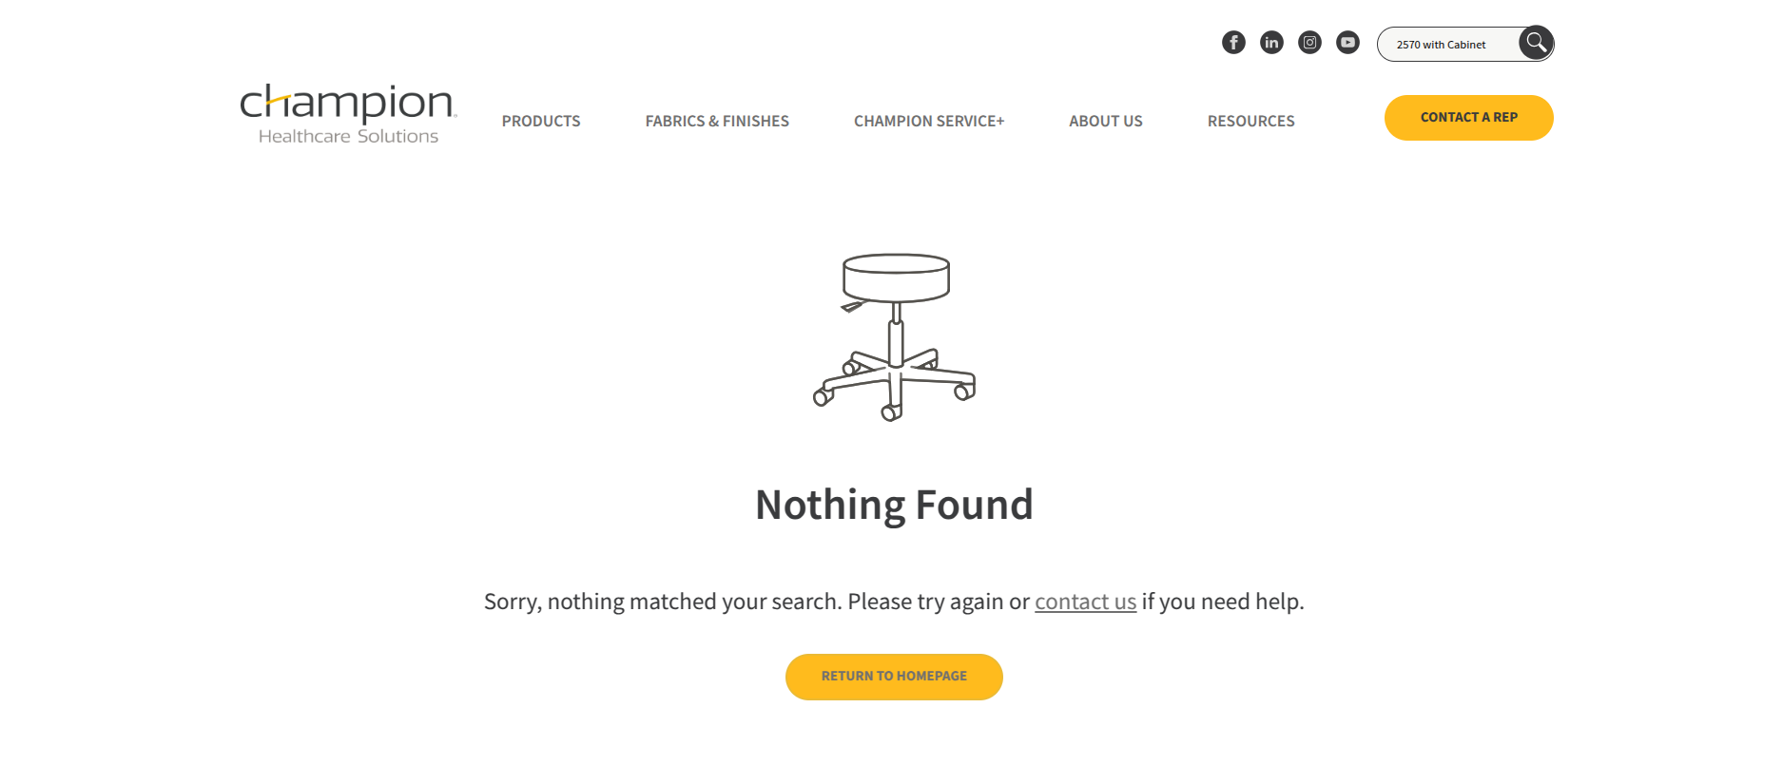

* **Using the mfr number as the search term**

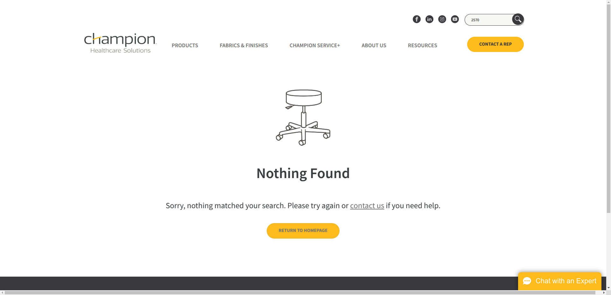

**Response:**

**#06 - Elevate | ELV8**

* **Using the model name as the search term**



**Result :**



* **Using the mfr number as the search term**

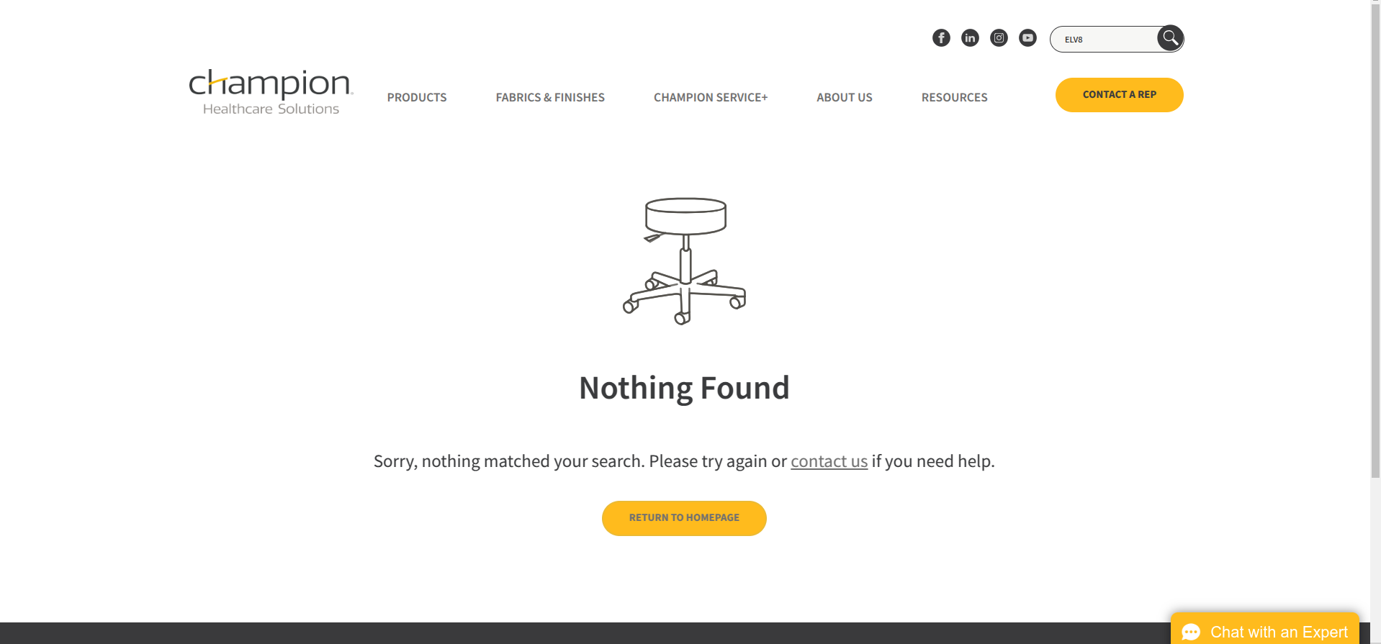

**Response:**

**#07 - 54 Series | 547XXX-TS7**

* **Using the model name as the search term**



**Result :**

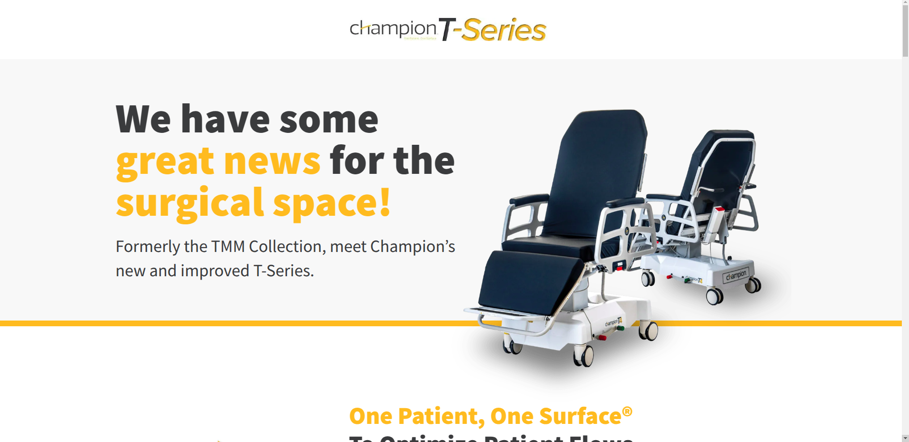

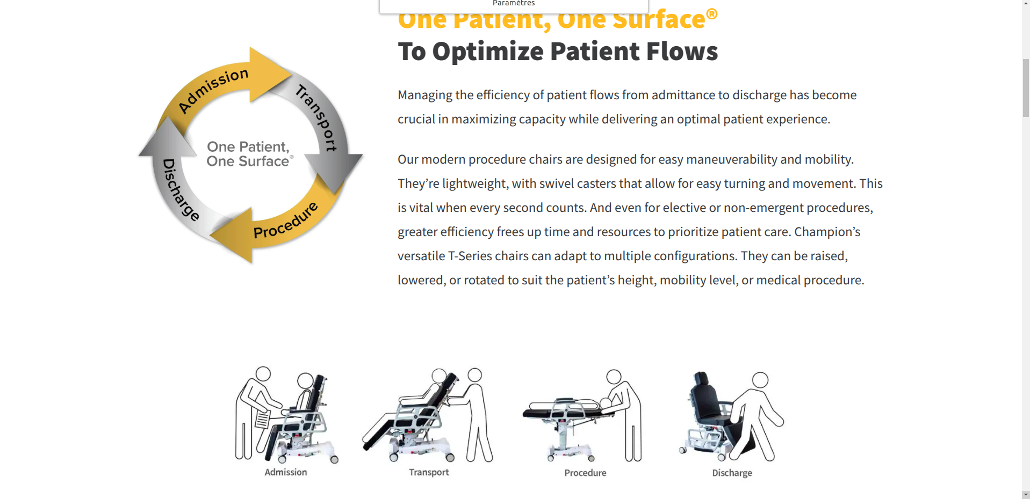

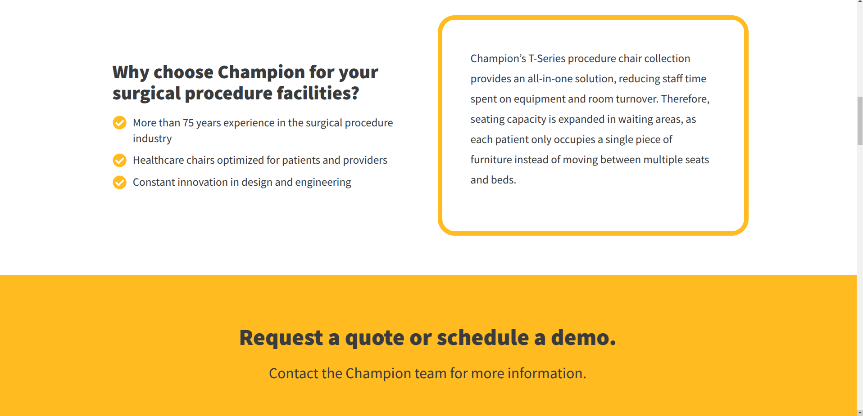

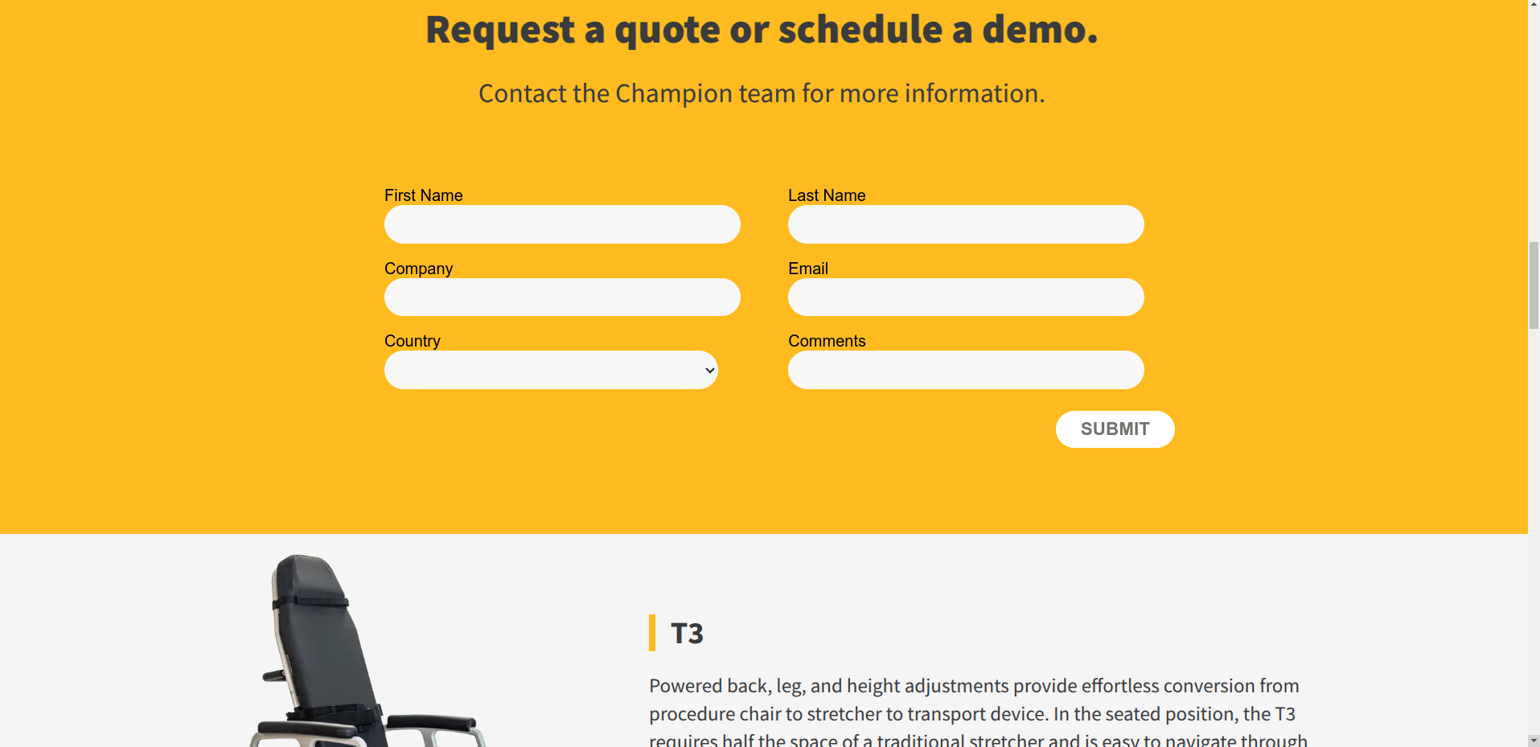

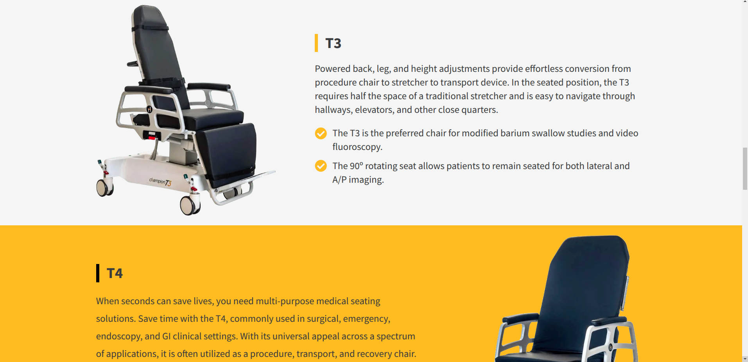

* **Using the mfr number as the search term**

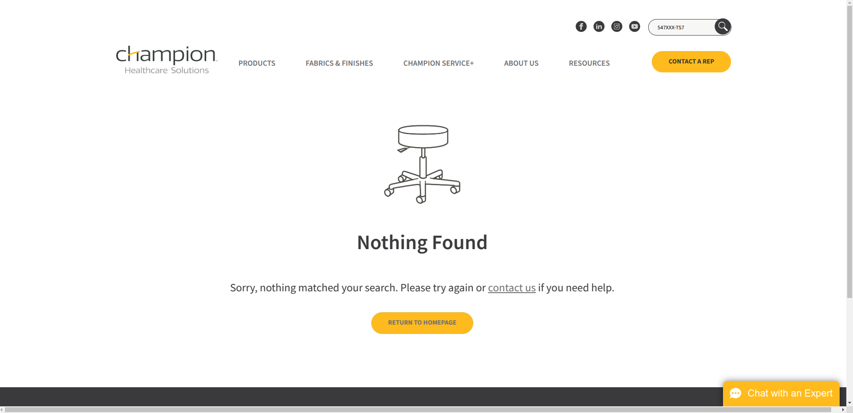

**Response:**

**#08 - 54 Series (Power) | 54PXXX-7**

**Using the model name as the search term**

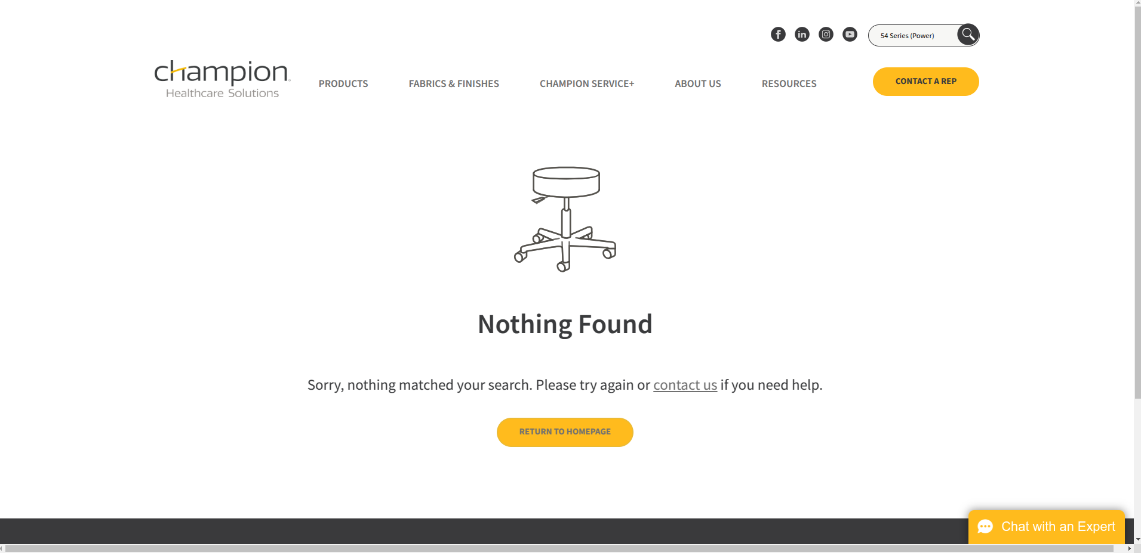

* **Using the mfr number as the search term**

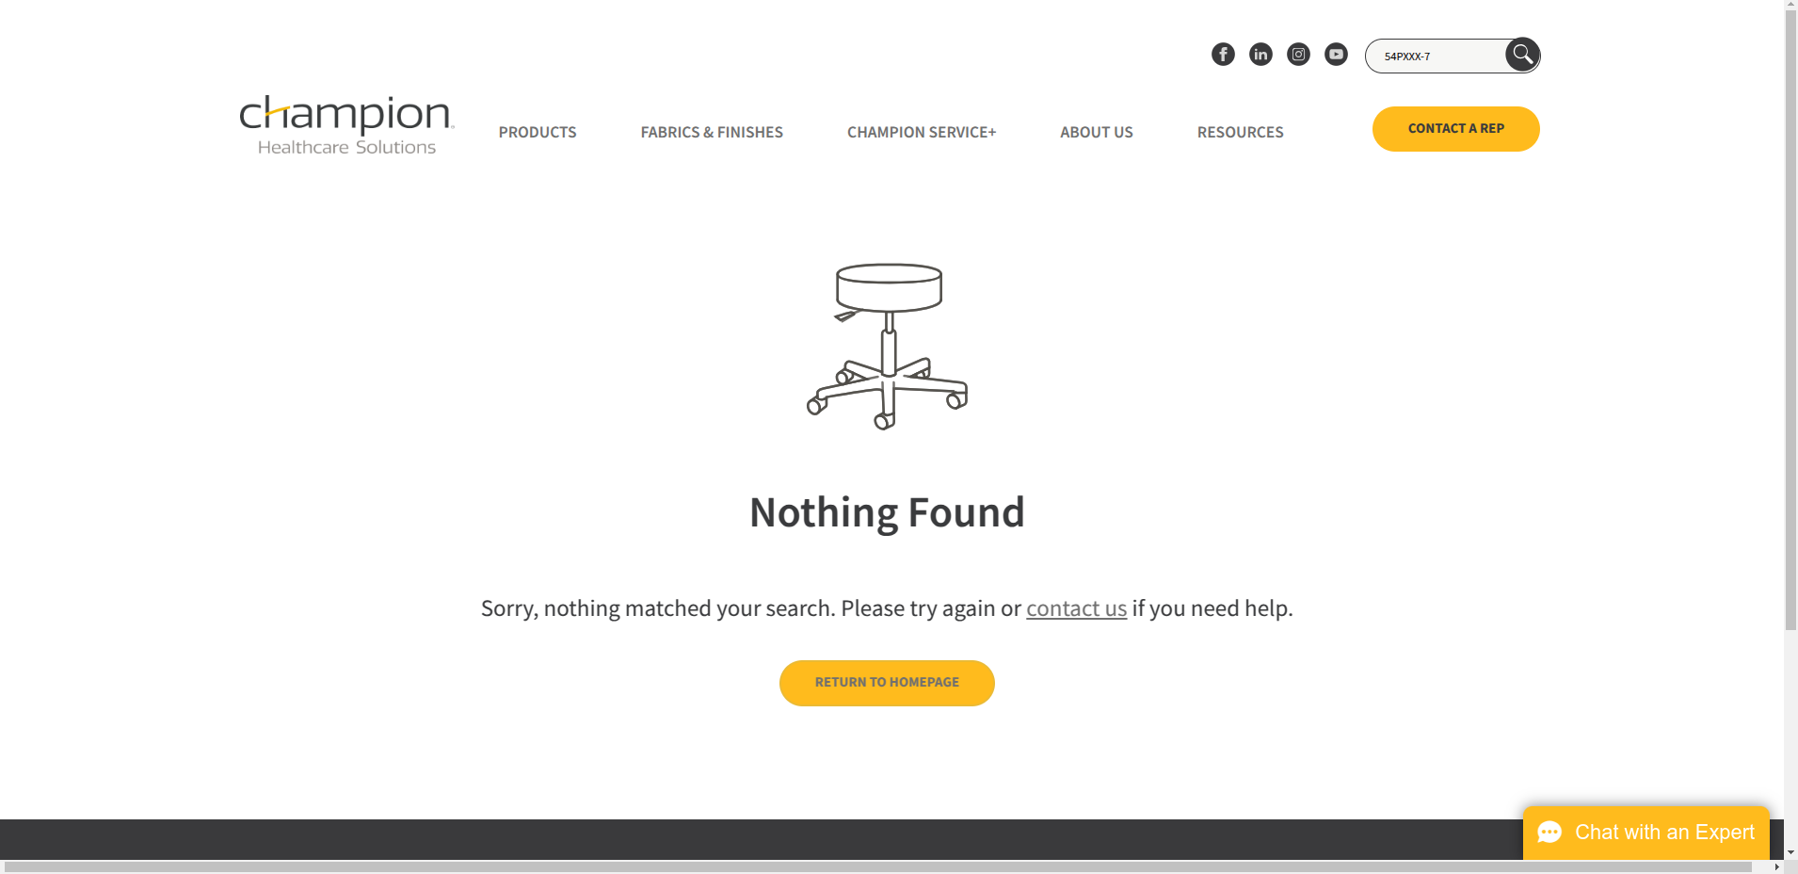

**Response:**

**#09 - 65 Series Ascent Recliner | 650**

* **Using the model name as the search term**

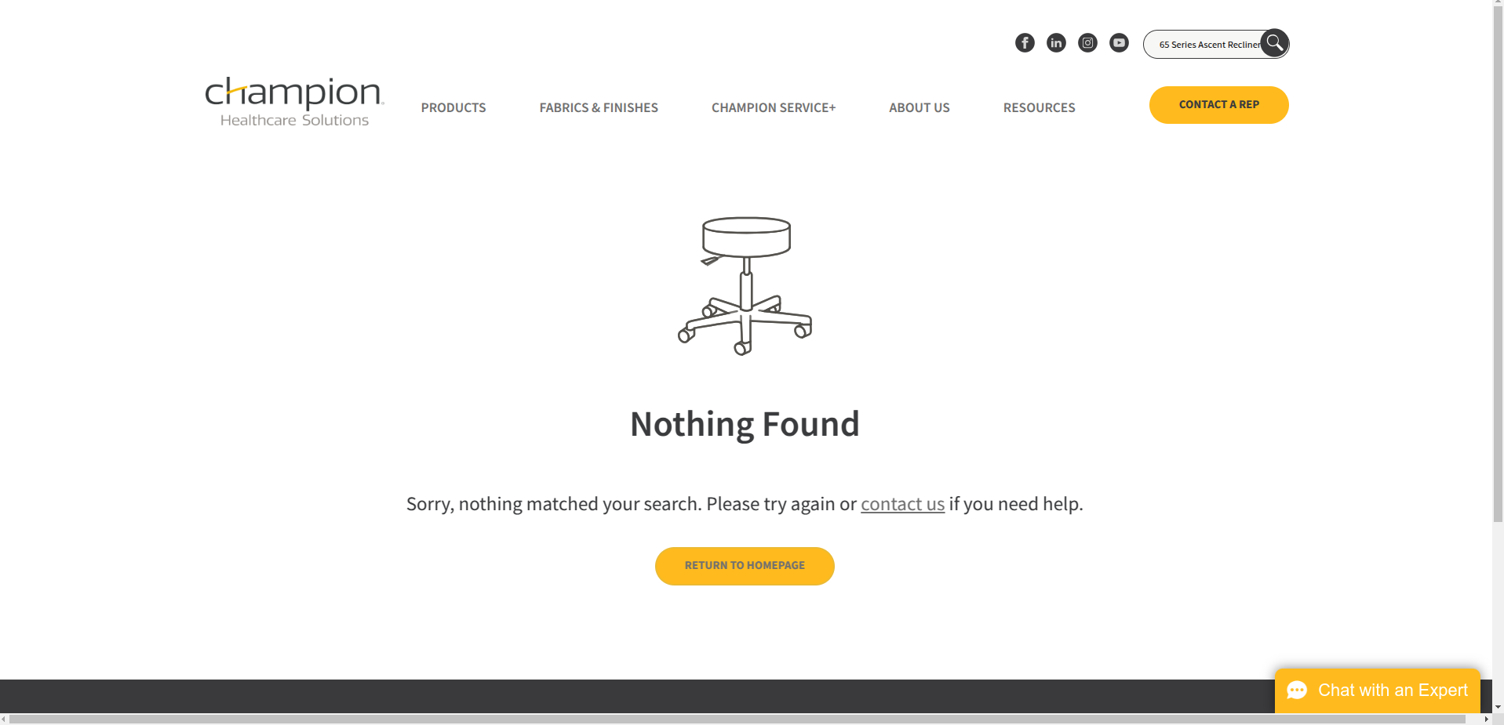

* **Using the mfr number as the search term**



**Result:**

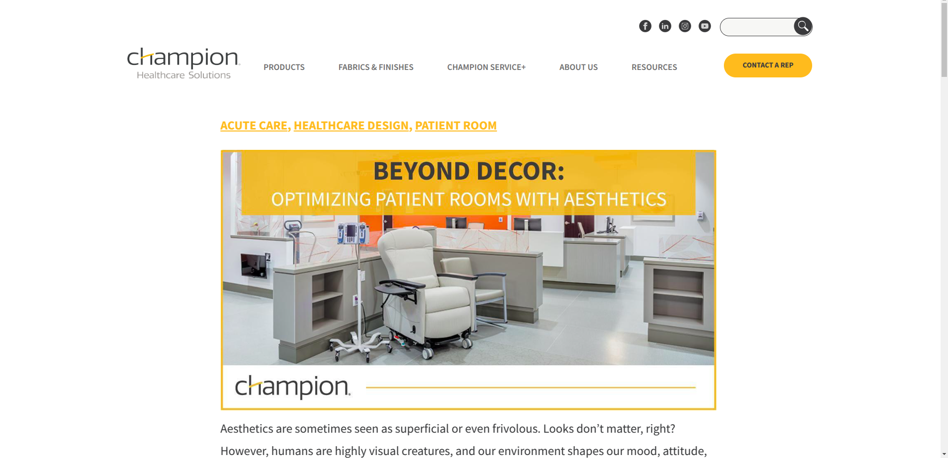

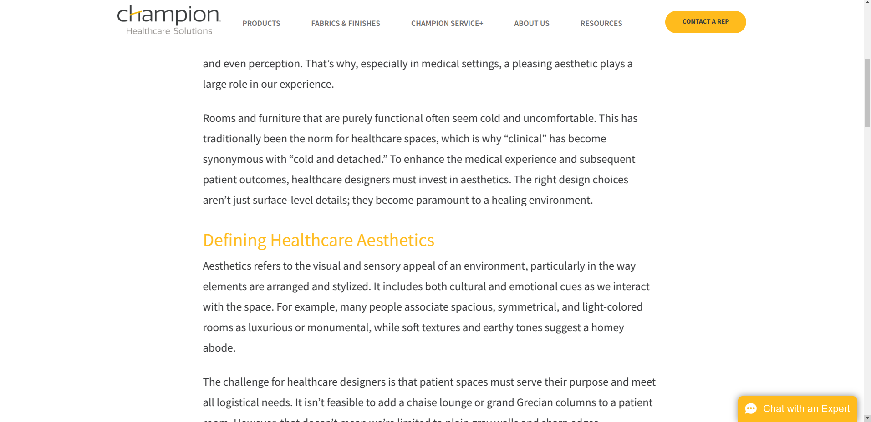

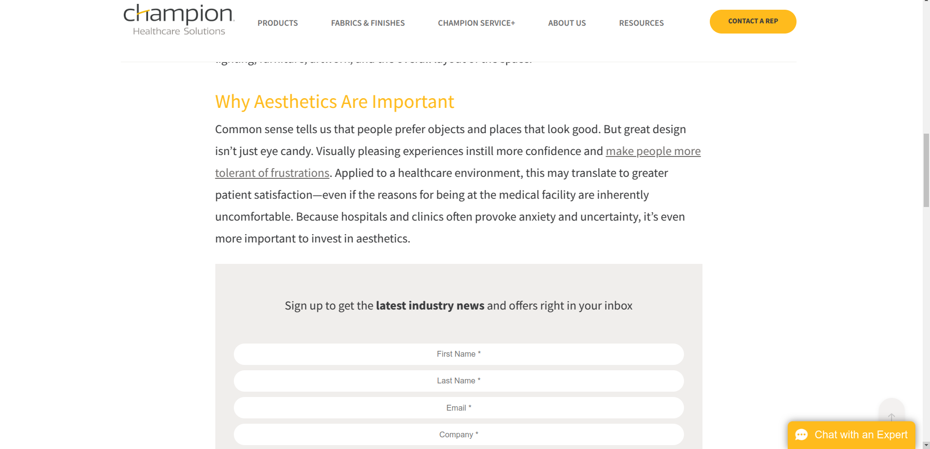

**Response:**

**#10 - Gas Lift Stool 430 | 430**

* **Using the model name as the search term**

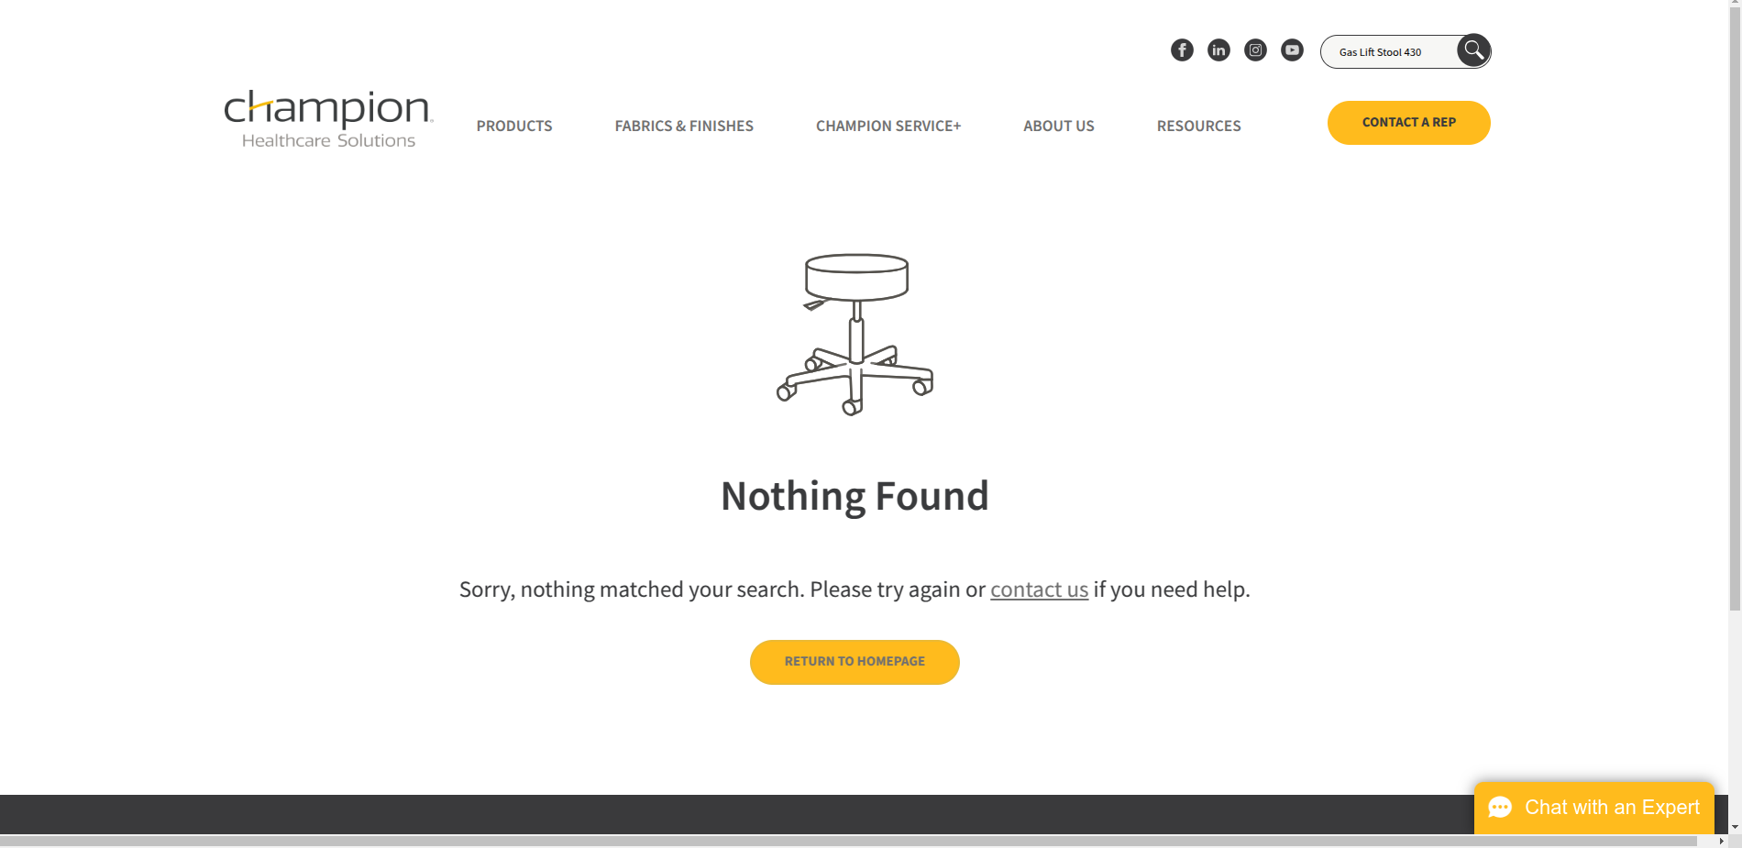

* **Using the mfr number as the search term**

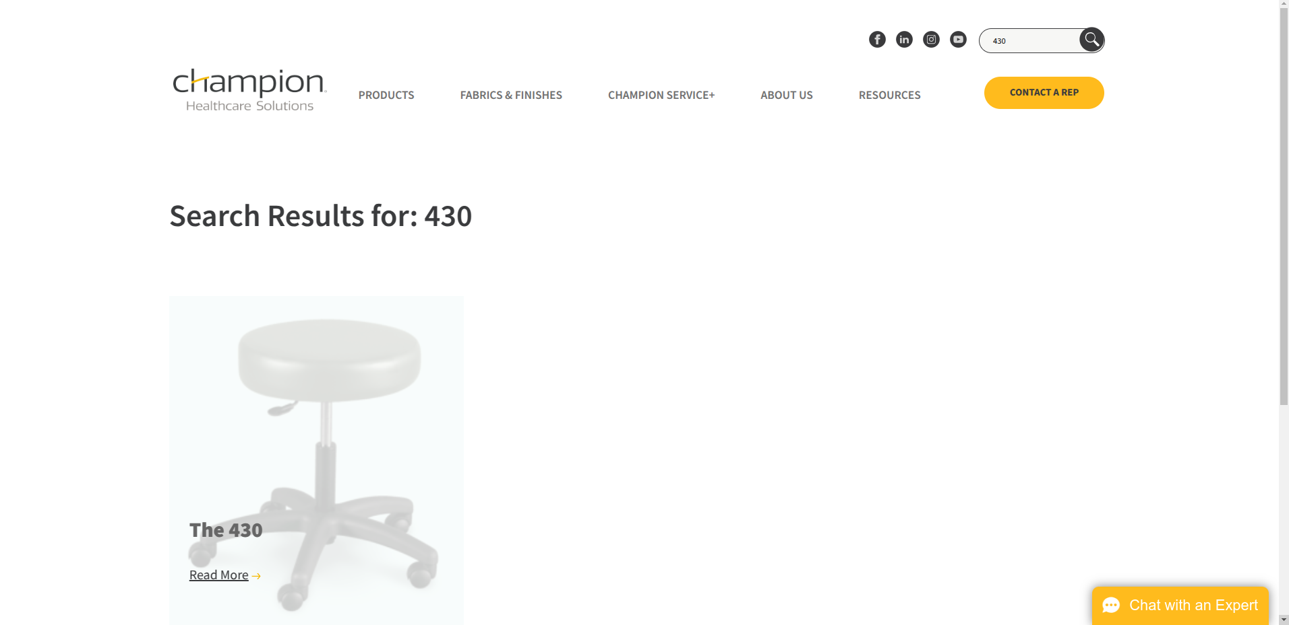

**Result:**

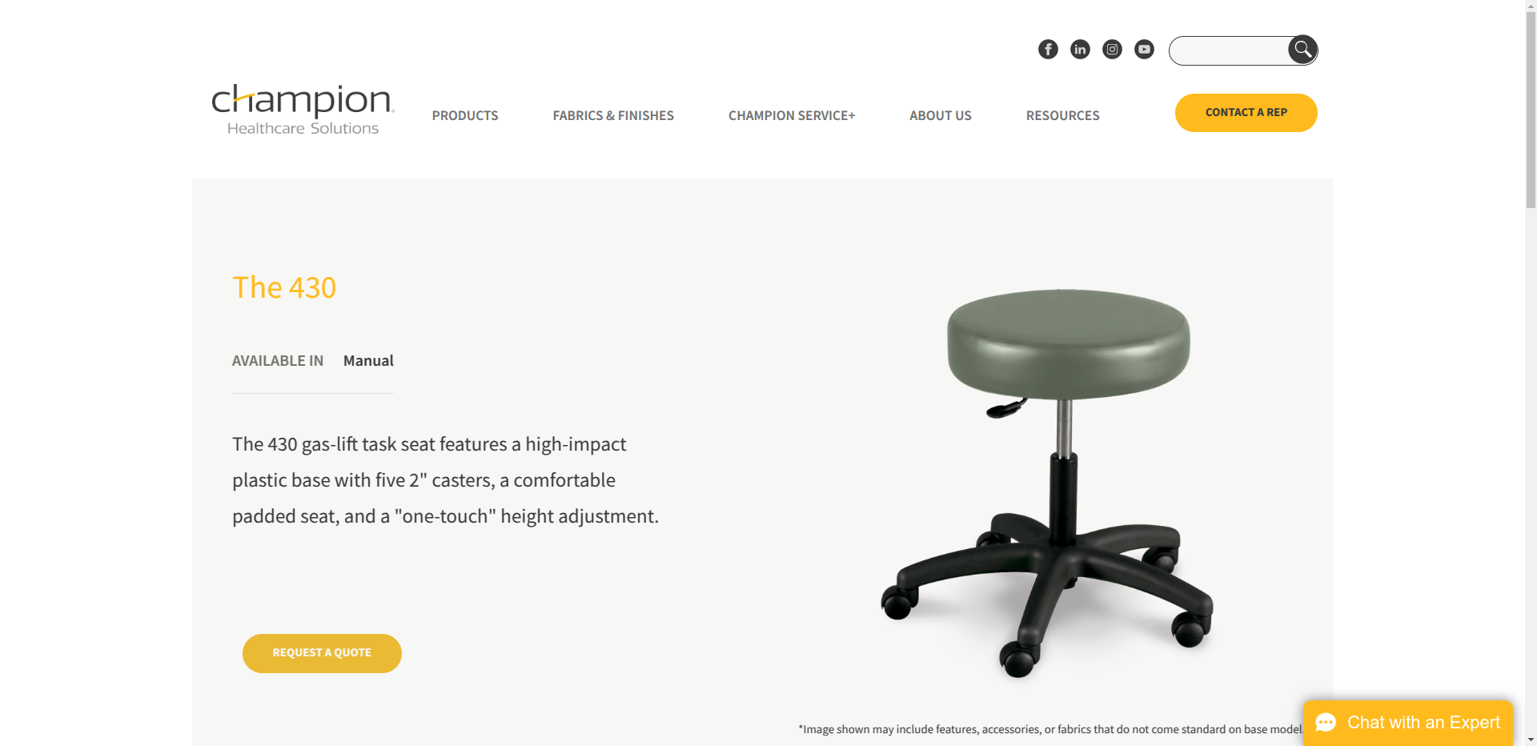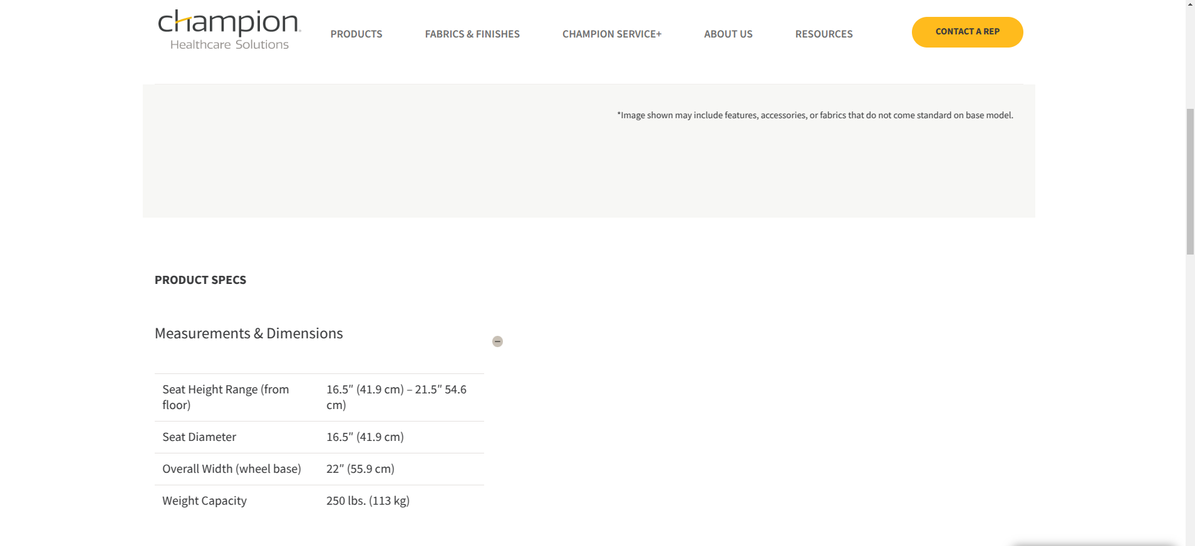

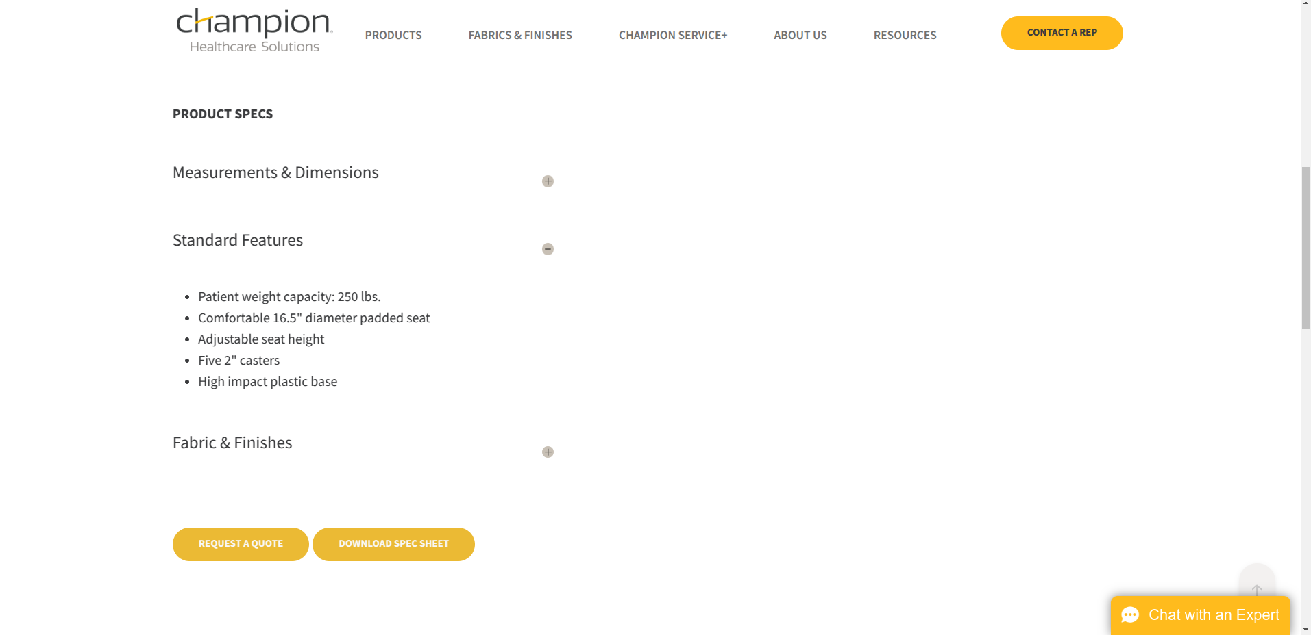

**Response:**

**#11 - 440 Deluxe Series Exam Stool | 440**

* **Using the model name as the search term**

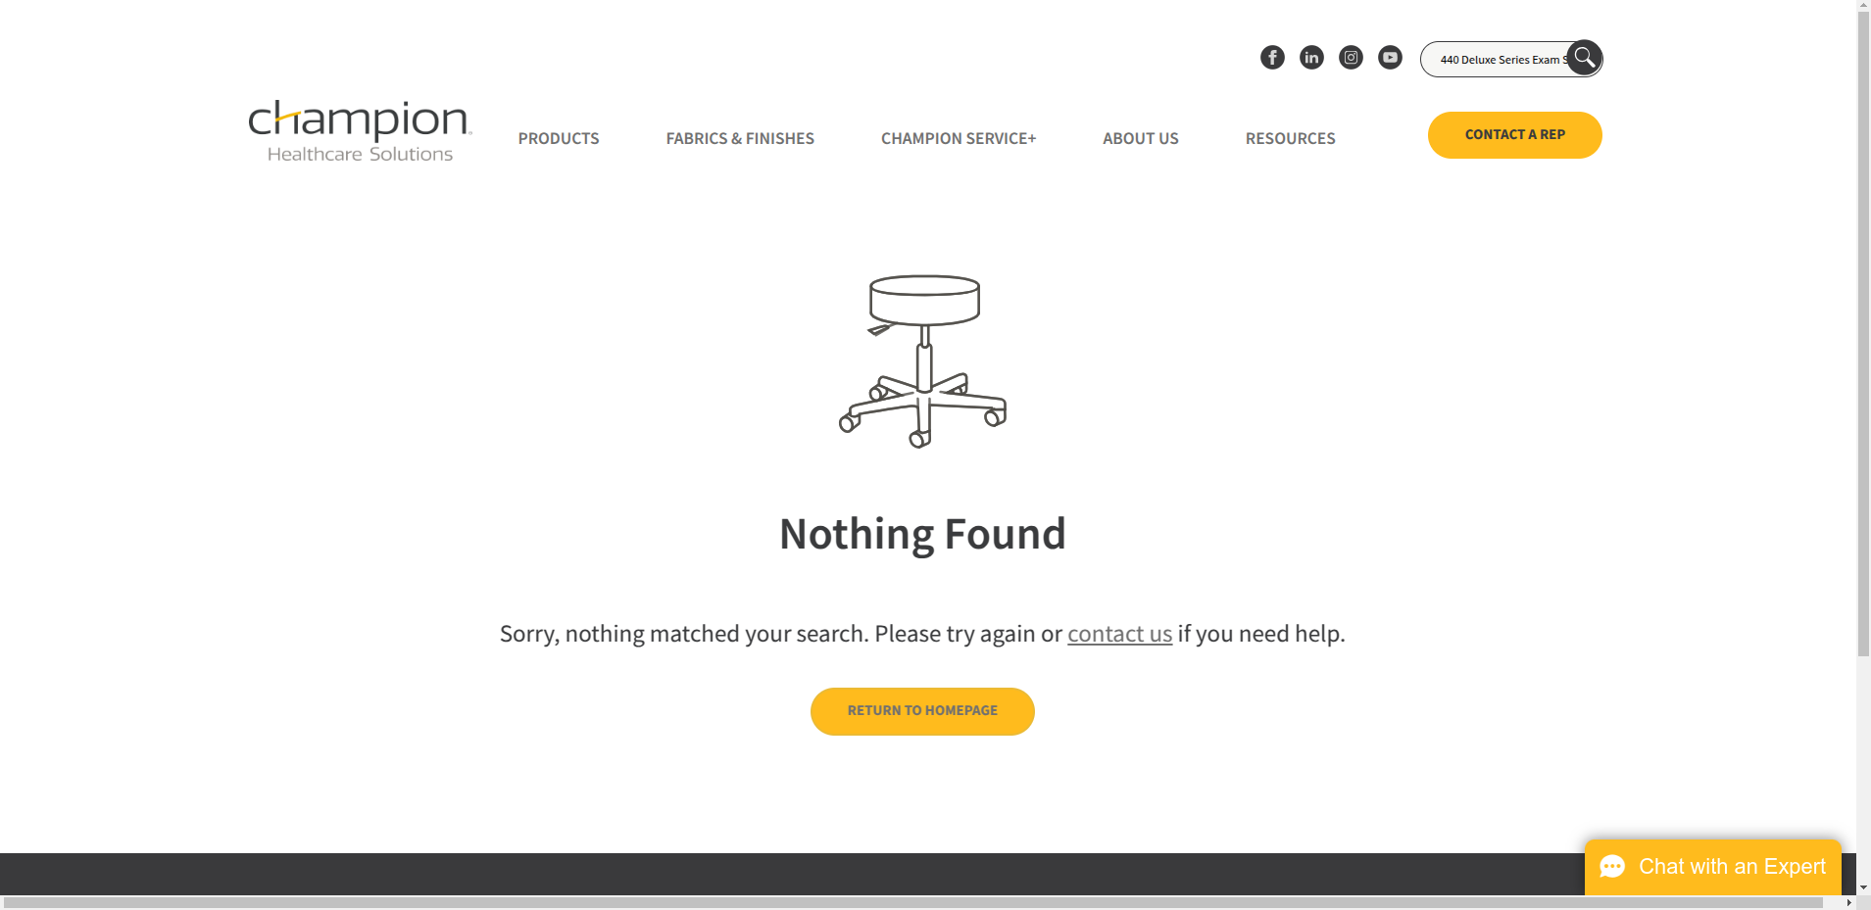

* **Using the mfr number as the search term**

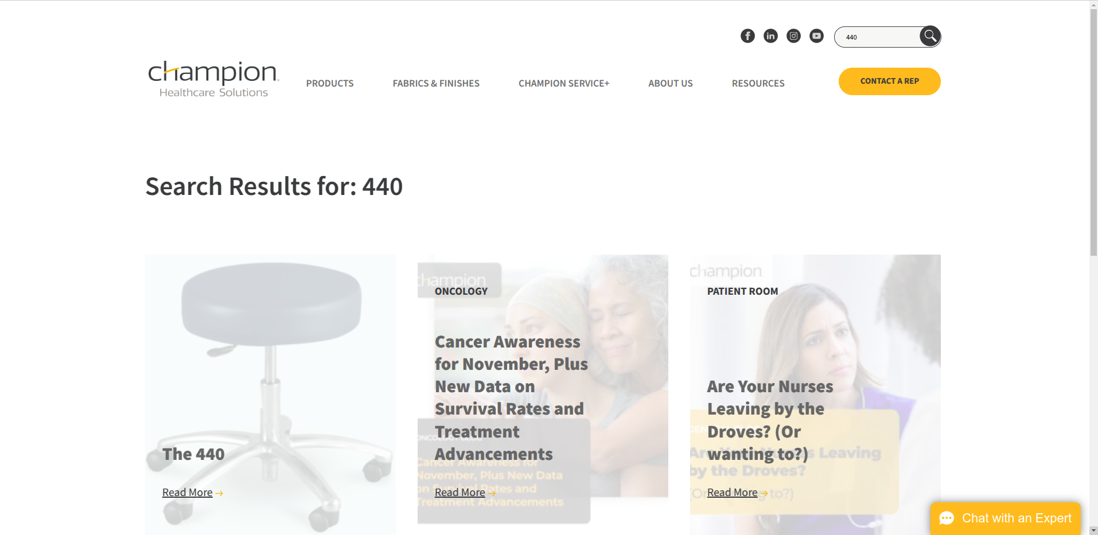

**Result:**

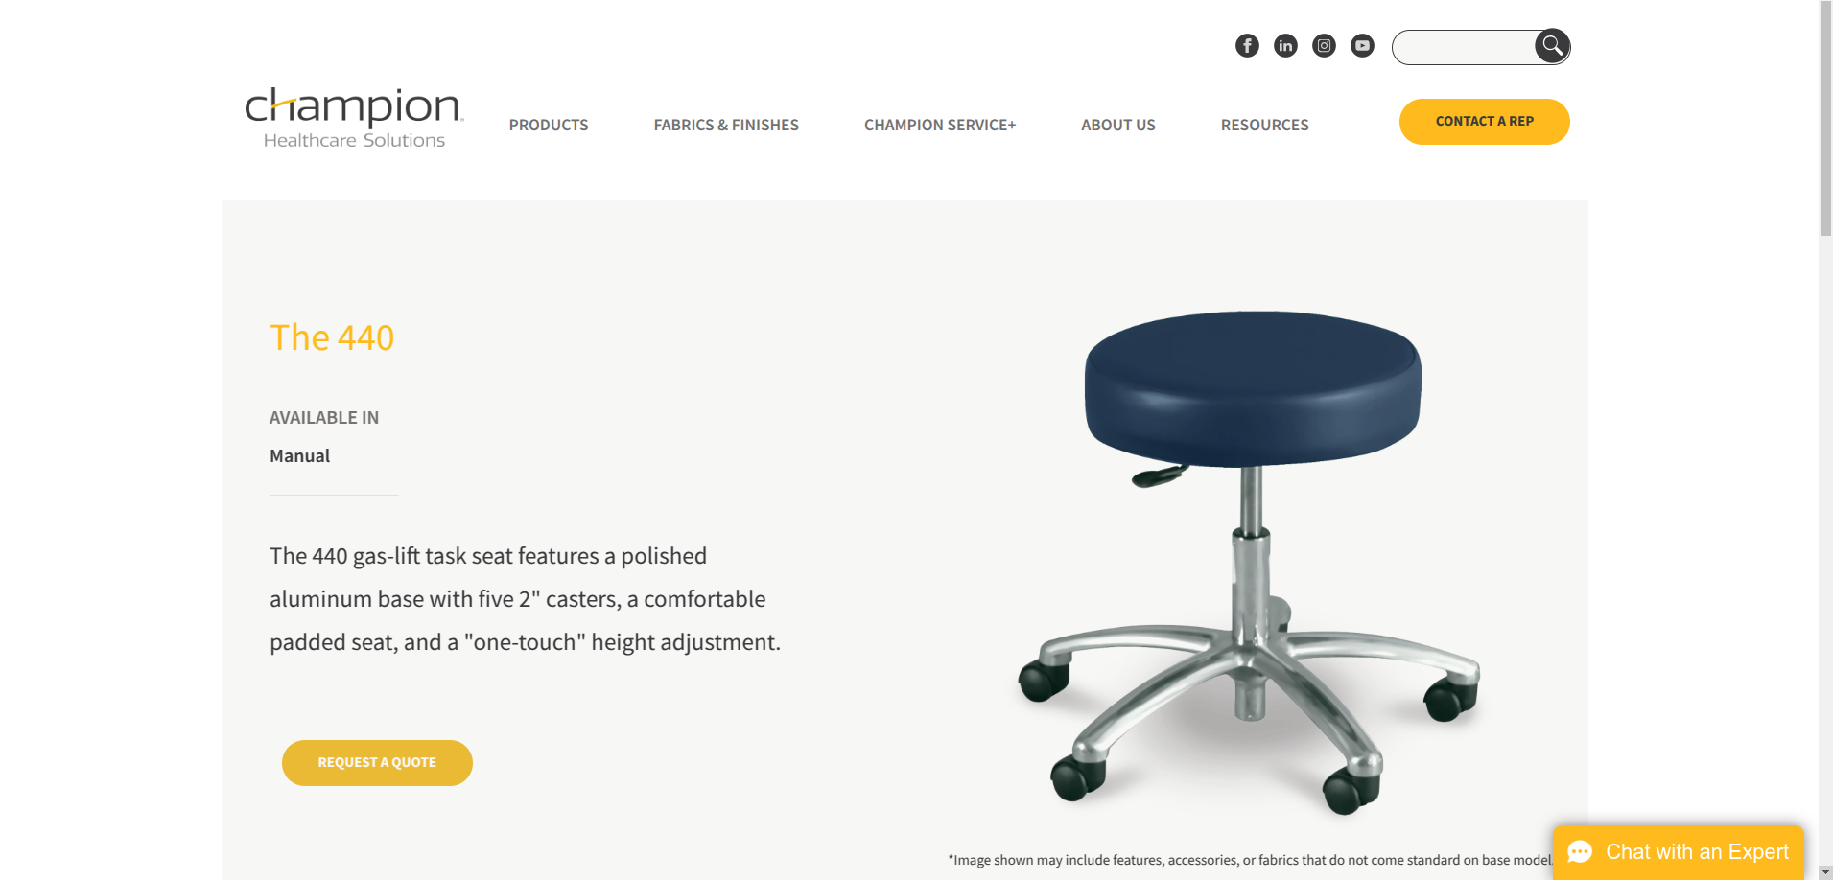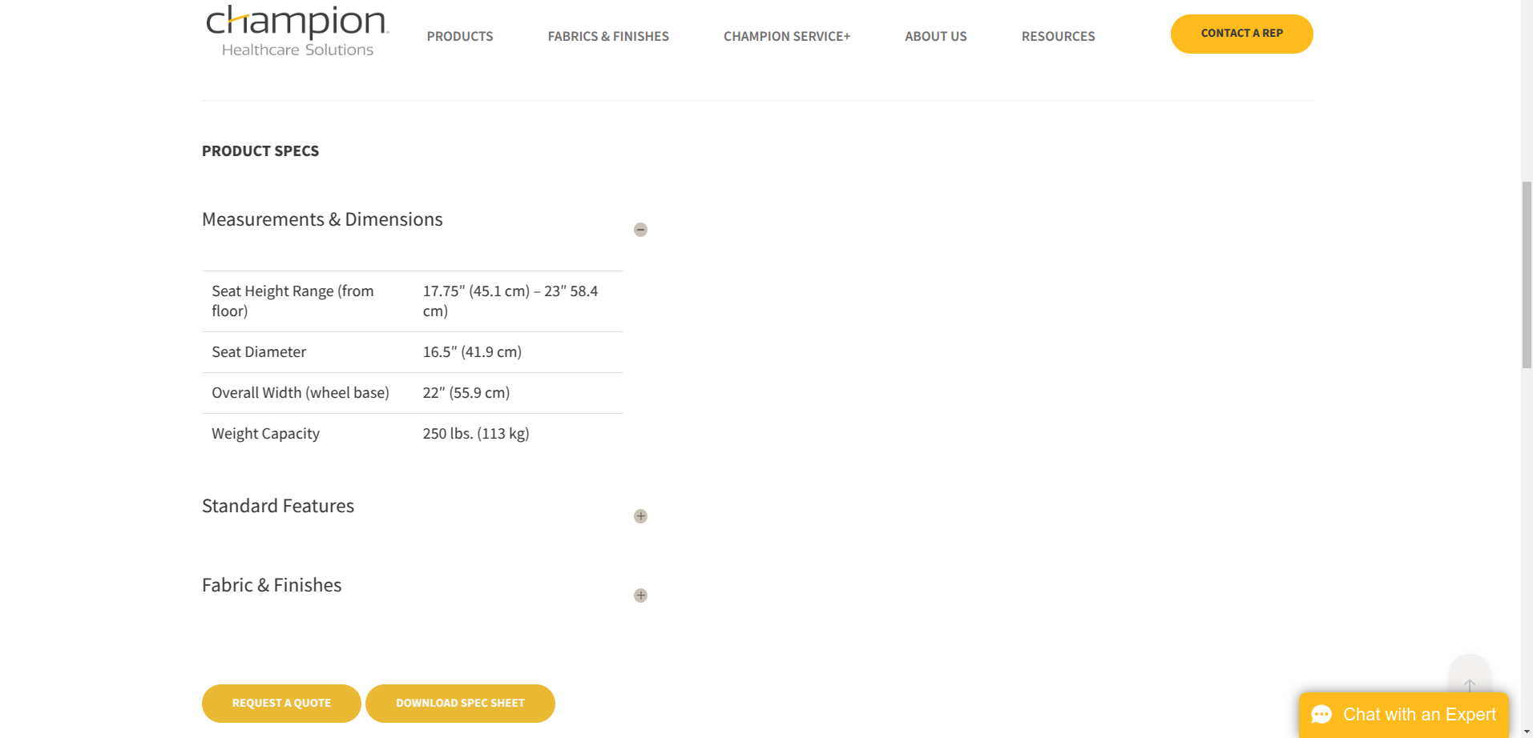

**Response:**

**#12 - Adjustable Back Treatment Table 8570 | 8570**

* **Using the model name as the search term**

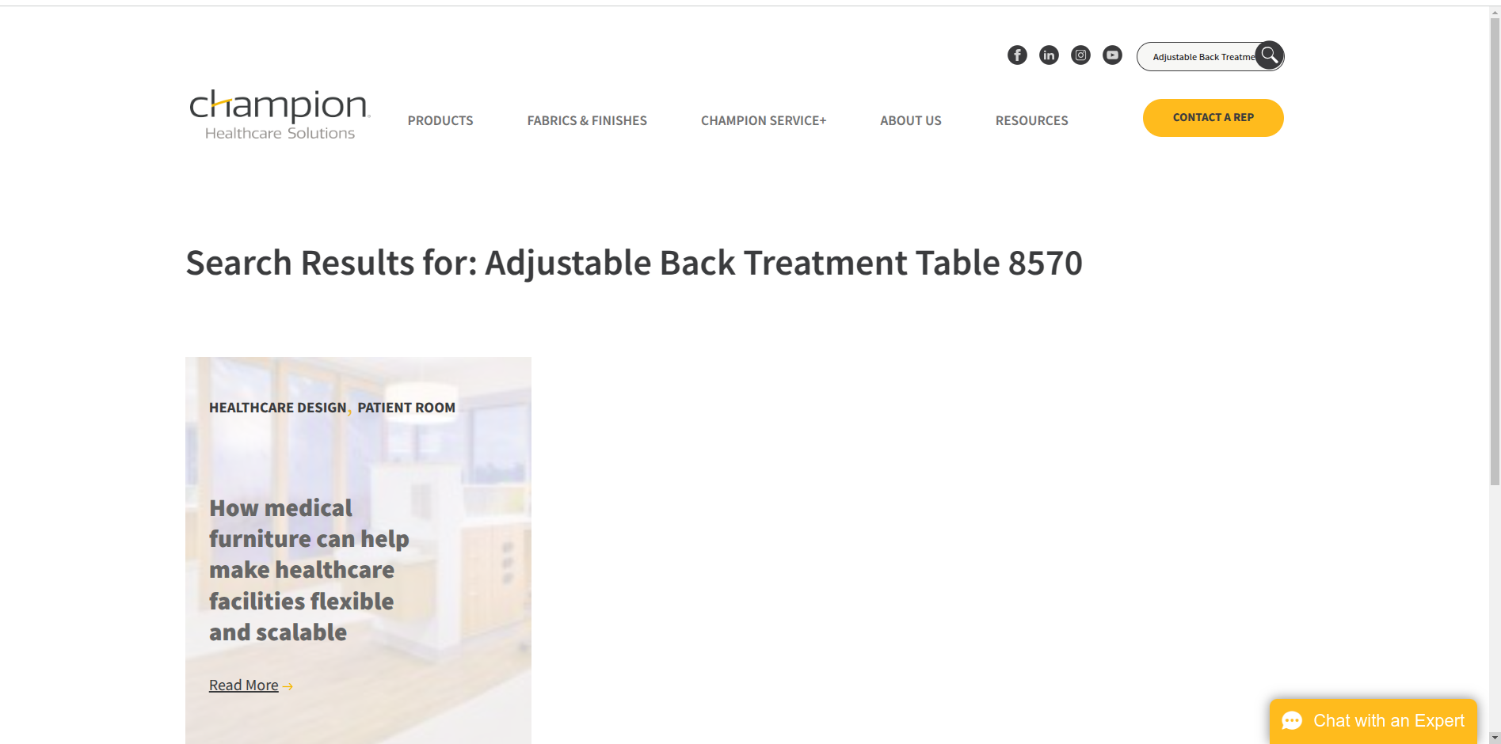

**Result :**

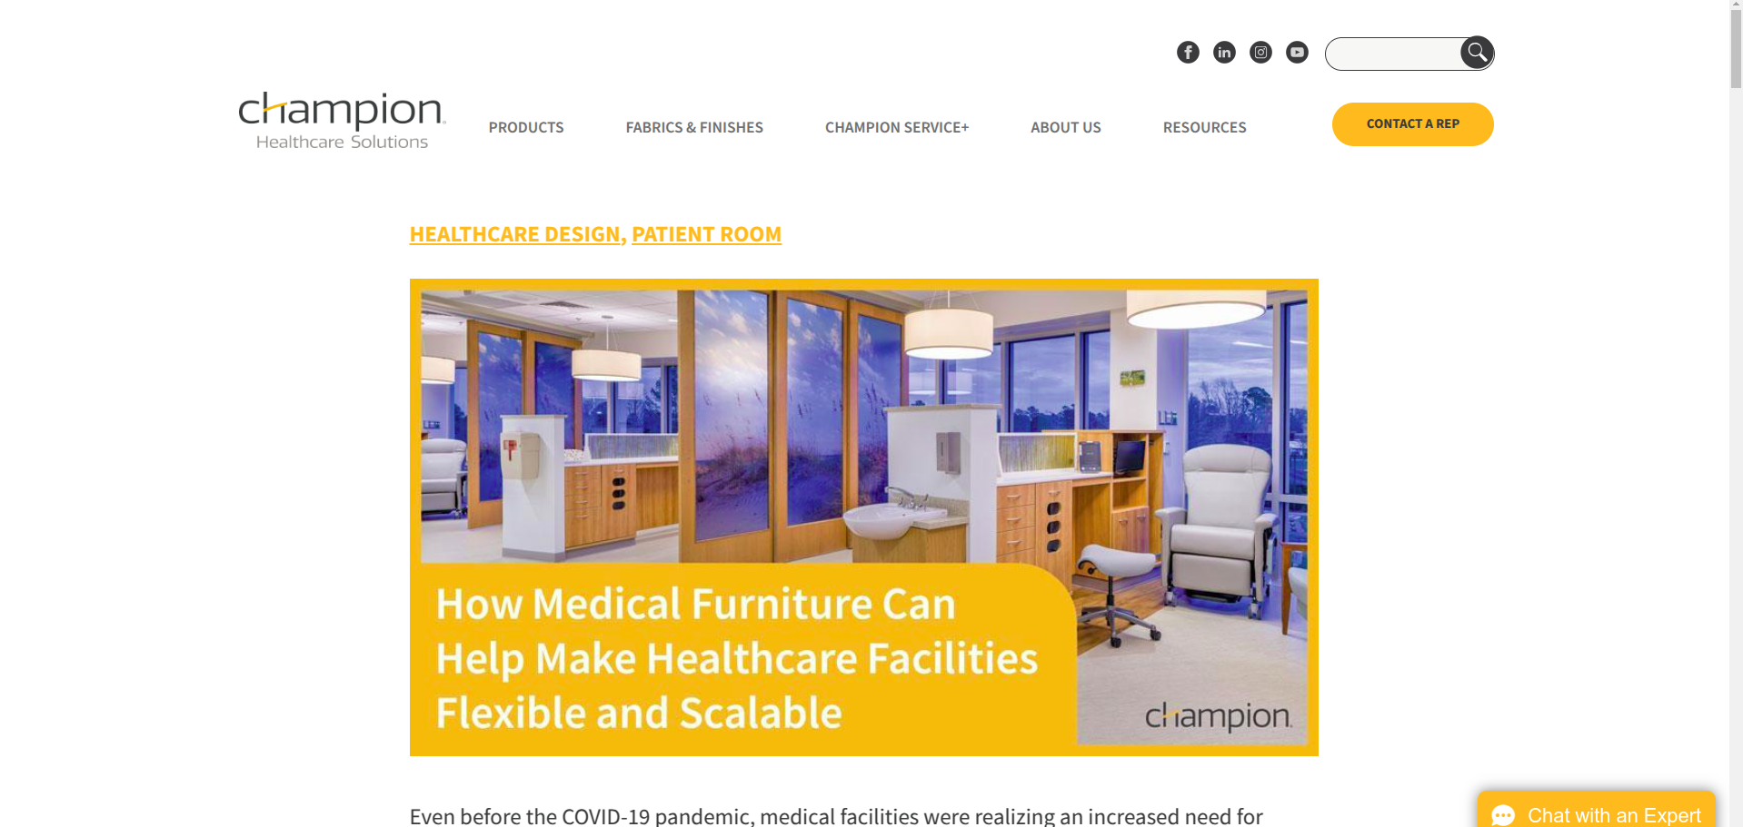

* **Using the mfr number as the search term**

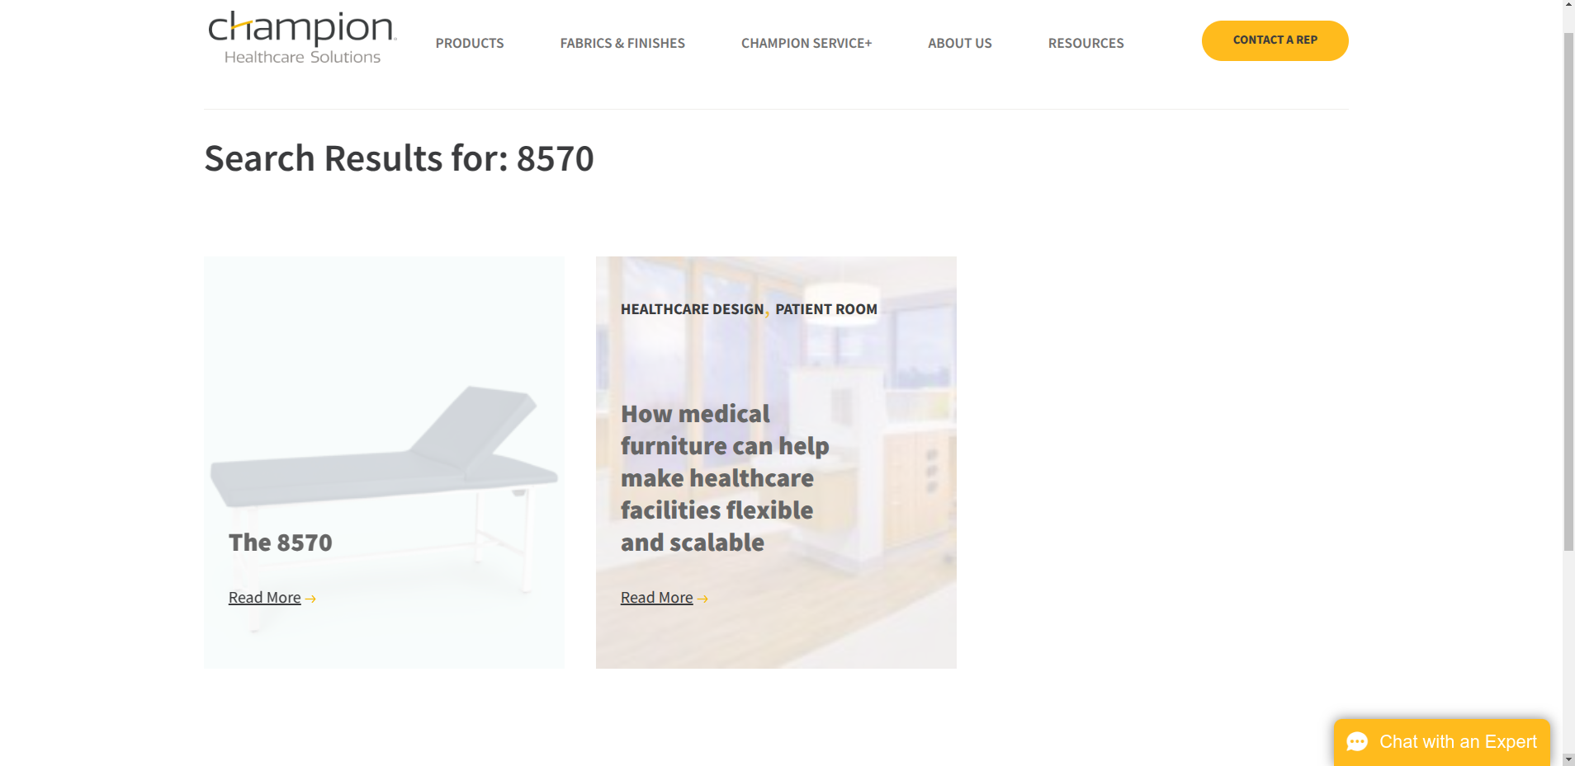

**Result:**

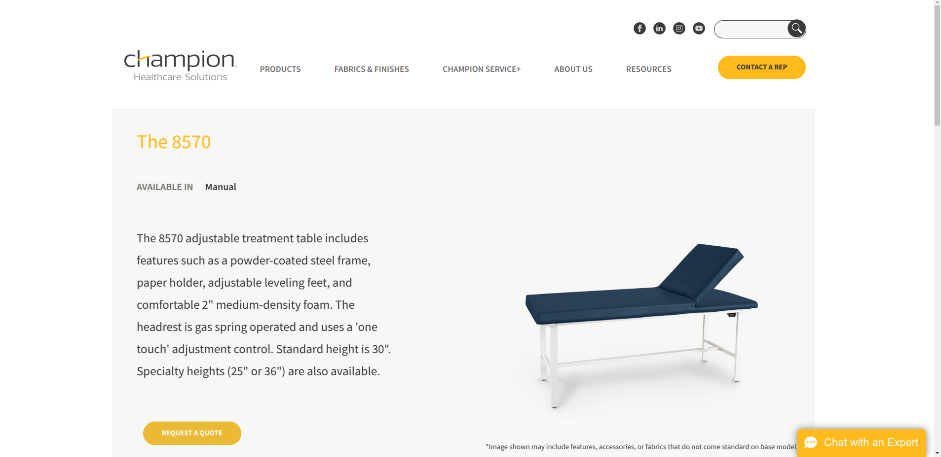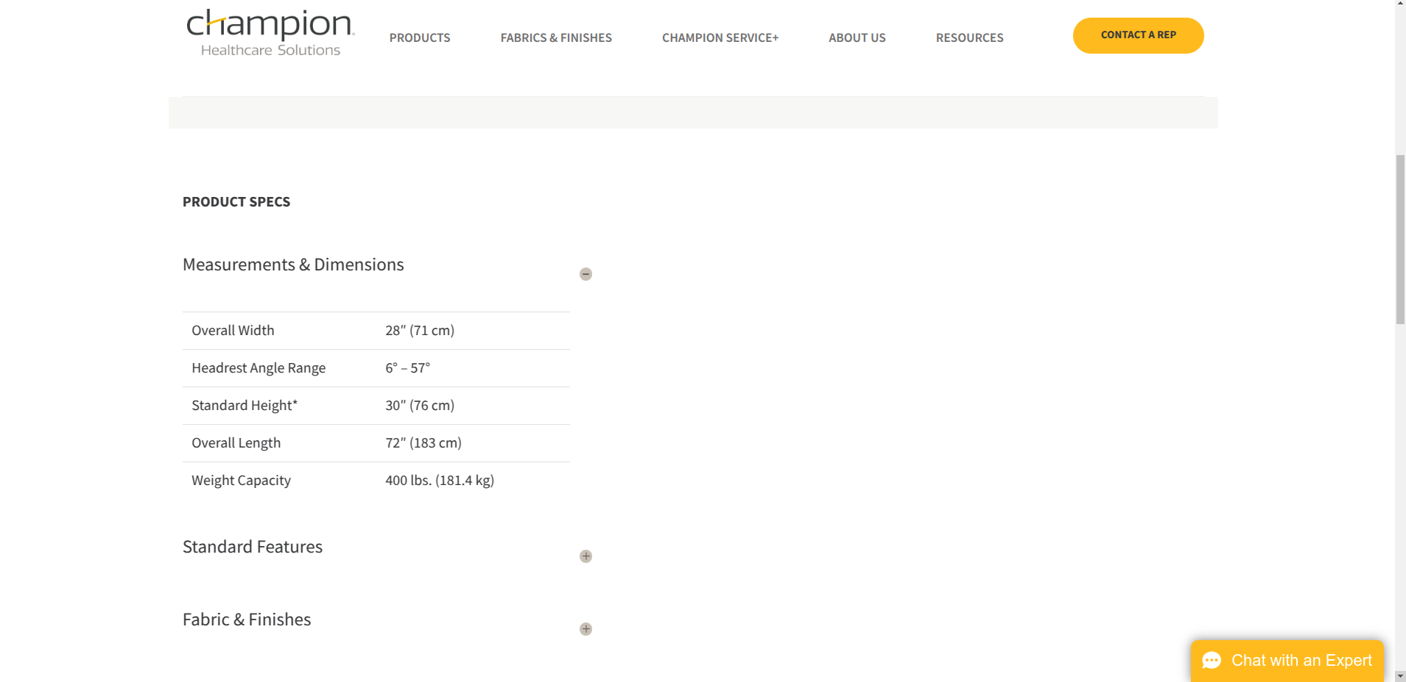

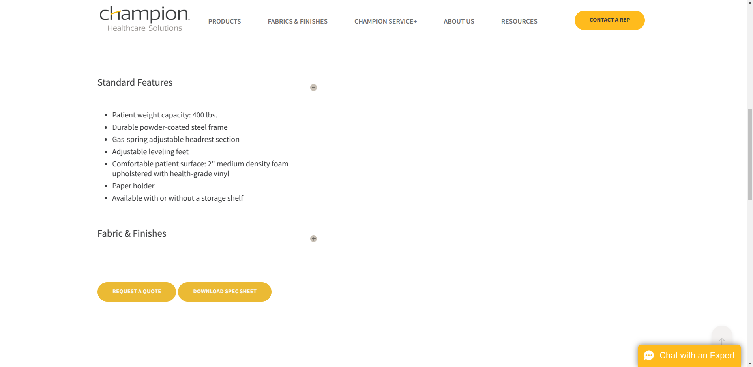

**Response:**